Steinbeck Country
A Two-Day Journey from San Francisco
Valley to Tidepools
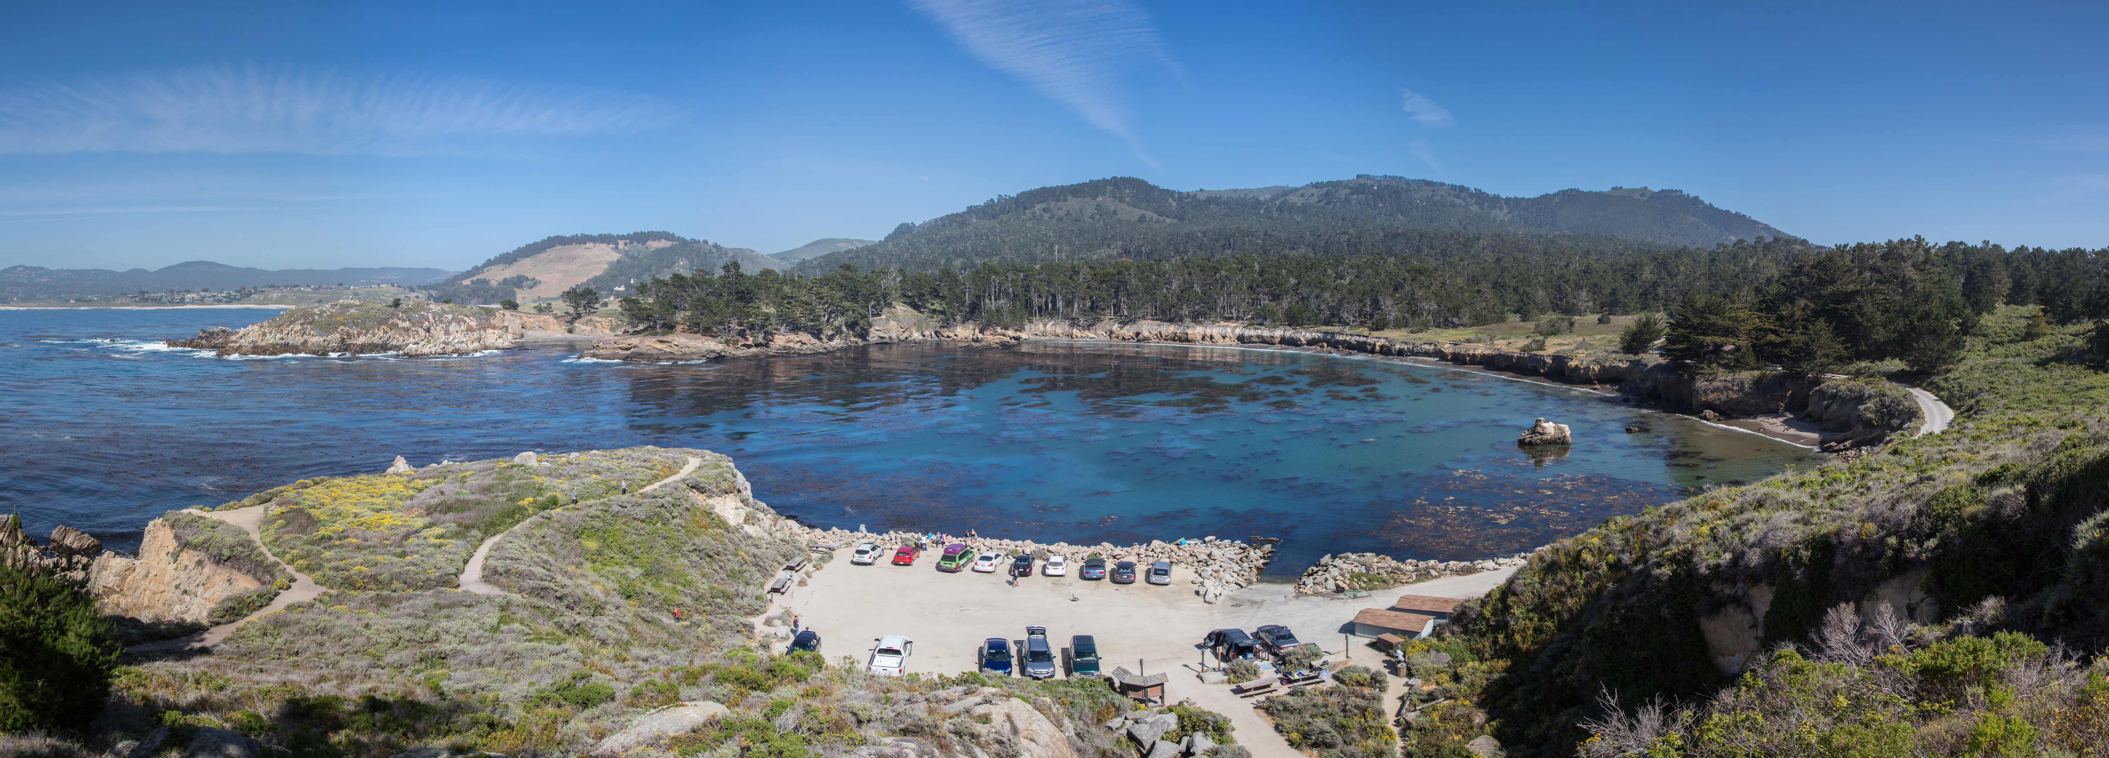
Whaler's Cove at Point Lobos State Natural Reserve
Route | Valley to Tidepools | Last verified | October 5, 2026
Travel dates | Add your travel dates | Travelers | Add traveler names
This guide moves from San Francisco to Moss Landing, Salinas, Cannery Row, Pacific Grove, Carmel, and Point Lobos. Keep the literary spine intact, but treat meal choices, pace, and overnight details as flexible planning decisions.
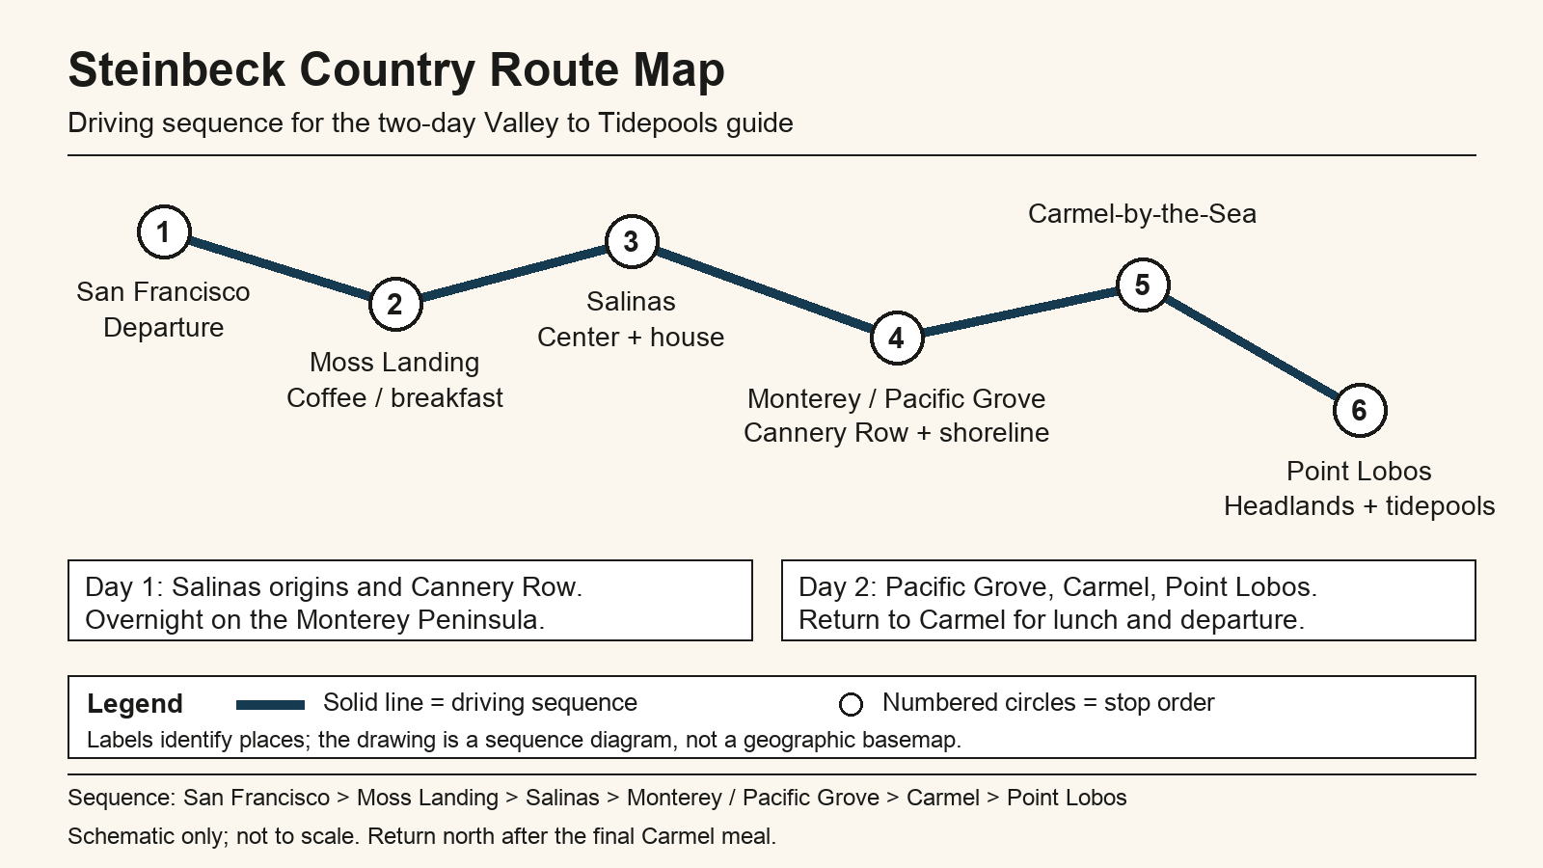
Schematic route map from San Francisco to Point Lobos

On-the-road quick sheet
The quick sheet keeps Valley to Tidepools legible at a glance. It foregrounds the first hard commitments—Power Plant Coffee, National Steinbeck Center, Pacific Biological Laboratories, and Point Lobos—before you fine-tune meals or shorten anything.
Day | Time | Stop | Route note | Map
1 | 8:00 AM | Depart San Francisco | Leave before commute thickens so Salinas still feels leisurely. | Map: Directions to Depart San Francisco
1 | 9:45 AM | Coffee break at Power Plant Coffee | Good first reset after Highway 101; pair coffee with a pie or breakfast sandwich. | Map: Directions to Coffee break at Power Plant Coffee
1 | 11:00 AM | National Steinbeck Center | Plan two hours; the museum itself suggests that window. | Map: Directions to National Steinbeck Center
1 | 1:15 PM | Lunch in Oldtown Salinas | Choose between literary atmosphere and a faster downtown lunch. | Map: Directions to Lunch in Oldtown Salinas
1 | 2:30 PM | Steinbeck House | 2:30 PM is gift-shop/exterior time; lunch ends at 2 PM. Check current tour dates. | Map: Directions to Steinbeck House
1 | 3:45 PM | Salinas Valley field-edge viewpoint | Use the drive west to notice how quickly row crops give way to coastal light. | Map: Directions to Salinas Valley field-edge viewpoint
1 | 5:00 PM | Cannery Row and Pacific Biological Laboratories exterior | The evening lab visit is exterior-only; interior access ends at 4 PM. | Map: Directions to Cannery Row and Pacific Biological Laboratories exterior
1 | 7:00 PM | Dinner in Monterey or Pacific Grove | Book ahead for Friday/Saturday evenings; keep the meal close to your inn. | Map: Directions to Dinner in Monterey or Pacific Grove
1 | 8:30 PM | Sunset walk or blue-hour shoreline pause | Lovers Point is the easiest low-effort finish if you still want one more scene. | Map: Directions to Sunset walk or blue-hour shoreline pause
2 | 8:00 AM | Breakfast in Pacific Grove | Choose a place near Central Avenue or Lighthouse Avenue for a quick start. | Map: Directions to Breakfast in Pacific Grove
2 | 9:15 AM | Pacific Grove shoreline + Steinbeck cottage exterior context | Treat the cottage as a respectful drive-by; it remains a private residence. | Map: Directions to Pacific Grove shoreline + Steinbeck cottage exterior context
2 | 10:45 AM | Carmel village walk | Park once and stroll the compact core before or after lunch. | Map: Directions to Carmel village walk
2 | 12:30 PM | Point Lobos State Natural Reserve | Aim for early arrival; the state park warns that parking fills quickly. | Map: Directions to Point Lobos State Natural Reserve
2 | 3:00 PM | Carmel lunch | A late lunch works well after Point Lobos if you carry water and a light snack. | Map: Directions to Carmel lunch
2 | 5:00 PM | Optional final meal or road snack | Pick up something portable before you commit to the northbound drive. | Map: Directions to Optional final meal or road snack
2 | 6:30 PM | Selig Farm on the return | Private stop on the northbound route; coordinate directly with the host before arriving. | Map: Directions to Selig Farm on the return

Choose your version
The default cut is narrative-first: Salinas on Day 1, the Monterey waterfront at dusk, then Pacific Grove, Carmel, and Point Lobos on Day 2. It is the cleanest way to feel the route move from farms and family history toward marine observation.

Prefer another path?
Swap emphasis without rewriting the whole guide. Keep the sequence, but shift time from museums to shoreline, from table-service meals to quicker snacks, or from Carmel strolling to extra Point Lobos trail time.
Version | Best for | What changes
Keep as written | First-time visitors who want the clearest Steinbeck-to-tidepools arc. | Hold the museum, house, Cannery Row, and Point Lobos at full length.  First drive leg: San Francisco to Moss Landing
Coastal-first | Travelers who care most about scenery and lighter museum time. | Trim Salinas lunch linger time, keep Cannery Row compact, and add time to Pacific Grove or Point Lobos.  Monterey hinge: Salinas to Cannery Row
Shorter return-day finish | Anyone who wants an earlier northbound departure. | Keep Point Lobos, then choose a fast Carmel lunch and portable final snack instead of a longer sit-down meal.  Final decision point: Carmel departure snack options

Historic lodging recommendations
Choose for walkability and atmosphere, not maximal amenities. The best overnight fit is the one that lets you finish Day 1 on foot and start Day 2 without a long repositioning drive.
Inn | Why stay | Practical notes | Link
Victorian Inn  Monterey | Role: primary  Its Cannery Row address keeps Day 1 walkable and makes Day 2's coastal start very easy. | Confirm current guest parking terms directly with the hotel when you book. | Hotel site: Visit Victorian Inn website
Green Gables Inn  Pacific Grove | Role: alternative  Best if you want a more romantic Pacific Grove mood and a shoreline-oriented morning start. | Onsite parking is available; confirm details because smaller inns can vary by room type. | Hotel site: Visit Green Gables Inn website
Old St. Angela Inn  Pacific Grove | Role: alternative  A good middle ground when you want historic character, quieter streets, and easy access to both Pacific Grove and Cannery Row. | Official site lists free on-site parking; reconfirm during booking. | Hotel site: Visit Old St. Angela Inn website

Day 1: Origins and Cannery Row
Day 1 moves from Power Plant Coffee through the National Steinbeck Center and Steinbeck House, then west to Cannery Row and Pacific Biological Laboratories before you settle into the peninsula for the night.
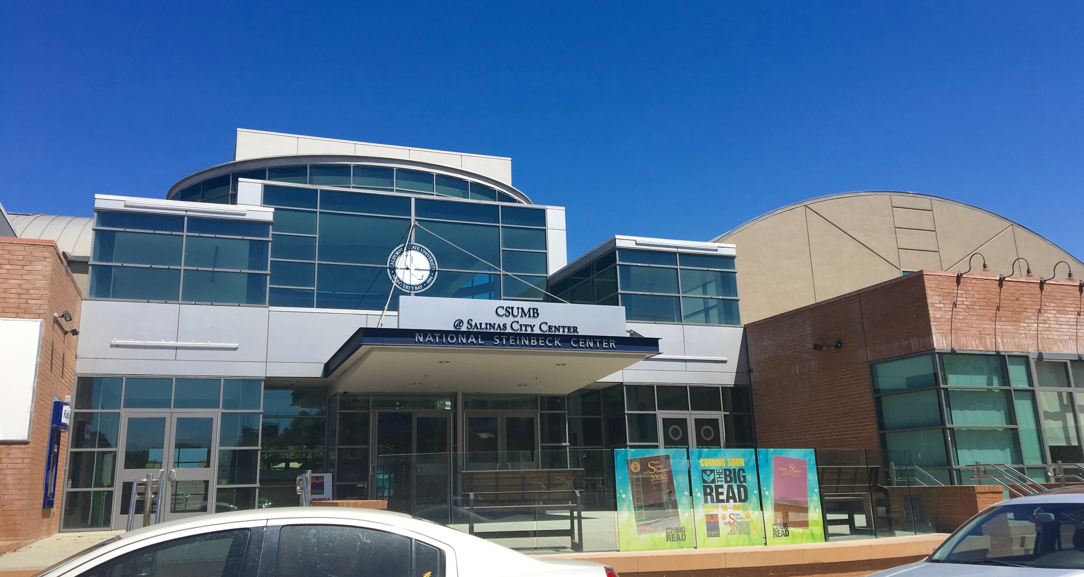
National Steinbeck Center in downtown Salinas
Time | Stop and context | Practical field notes
9:45 AM | Power Plant Coffee  Ease into the valley-and-bay mood with a Moss Landing reset  Moss Landing is where the road starts to loosen its grip on city pace.  Steinbeck connection: This stop sets up the trip's central movement from the agricultural world behind East of Eden toward the marine…  Look for: The shift in landscape: harbor equipment, slough birds, and produce trucks sharing the same horizon.  Prefer another path?: Elkhorn Slough overlook pull-off (40 min): Travelers skipping the literary frame can swap coffee for an immediate…  Sources: The Power Plant Coffee & Store; Restaurantji. | Address: 7990 Highway 1, Moss Landing, CA 95039  Primary duration: 45 minutes  Parking: Easy lot parking is part of the appeal; if the main spaces are busy, nearby Moss Landing businesses create overflow competition on weekends.  Reservation / access: Walk-in cafe; Sunday-Friday 7 AM-4 PM and Saturday 7 AM-5 PM. Reconfirm holiday hours.  Weather / closure plan: If the morning is foggy or windy, keep this as a short indoor stop and save your outdoor lingering for Pacific Grove or Point Lobos. If closed, use Moss Landing Cafe or La Fortuna Bakery from the meal card.  Map: Directions to Power Plant Coffee
11:00 AM | National Steinbeck Center  Enter the Salinas Valley through its storyteller  If the road trip has a formal threshold, it is here.  Steinbeck connection: The center interprets Steinbeck's life and works, including the Salinas roots behind East of Eden, The Red Pony, and The Pastures of Heaven.  Look for: Notice how often place names, crops, and family tensions are tied back to actual valley geography.  Prefer another path?: Oldtown Salinas architecture and mural walk (90 min): It keeps you in the historic center with a lighter civic-history focus if…  Sources: National Steinbeck Center. | Address: 1 Main Street, Salinas, CA 93901  Primary duration: 120 minutes  Parking: The adjacent downtown garage is the easiest option; bring a card and leave a few extra minutes if Salinas has an event downtown.  Reservation / access: General admission is usually simple at the door, but timed group visits and school traffic are worth checking on the center's visit page before you travel.  Weather / closure plan: This is your best all-weather anchor on Day 1, so let it absorb extra time if rain or valley wind makes outdoor stops less inviting. If the museum is closed, use the Oldtown architecture walk and bring lunch forward.  Map: Directions to National Steinbeck Center
1:15 PM | Salinas lunch  Pause among the blocks that still feel like a working hometown  Lunch in Salinas should feel grounded rather than polished.  Steinbeck connection: Downtown Salinas supplies the everyday social texture behind Steinbeck's recurring attention to workers,…  Look for: Menus that lean on local produce are a quiet reminder of the valley's agricultural identity.  Prefer another path?: Oldtown produce-and-coffee ramble (45 min): A traveler who wants something lighter can turn lunch into a shorter…  Sources: See Monterey; See Monterey. | Address: Oldtown Salinas, Salinas, CA 93901  Primary duration: 60 minutes  Parking: Street parking is workable around Main Street and Central Avenue, but read time limits so lunch does not complicate the afternoon.  Reservation / access: For the Steinbeck House dining room, call ahead; for the faster downtown spots, same-day walk-ins are usually the point.  Weather / closure plan: If the day runs late, choose the quickest lunch option and save lingering for Cannery Row or Pacific Grove. If your first choice is closed, use another lunch-card option and check its service days.  Map: Directions to Salinas lunch
2:30 PM | Steinbeck House  See the Victorian frame around the writer's beginnings; interior access is scheduled  The Steinbeck House works best as a human-scale counterpoint to the museum.  Steinbeck connection: This restored Queen Anne Victorian is Steinbeck's birthplace and boyhood home, now operated as a restaurant and…  Look for: Notice how the house's domestic scale changes your sense of Steinbeck from icon to local son.  Prefer another path?: Salinas historic-district Victorian walk (45 min): It keeps the architectural mood while removing the literary focus for…  Sources: The Steinbeck House; See Monterey. | Address: 132 Central Avenue, Salinas, CA 93901  Primary duration: 60 minutes  Parking: Use nearby street spaces and arrive with a little patience; the house sits in a residential-feeling part of downtown rather than a big visitor lot.  Reservation / access: Lunch is Tuesday-Saturday 11:30 AM-2 PM; gift shop 11 AM-3 PM. At 2:30 PM, plan on the gift shop and exterior, not lunch or an unscheduled house tour. Check the current tour calendar and reserve by phone where required.  Weather / closure plan: If the house is closed, keep the exterior stop brief and spend the extra time on the valley drive or Cannery Row.  Map: Directions to Steinbeck House
3:45 PM | Salinas Valley field-edge viewpoint  Let the valley become a character before you trade it for the sea  A short field-edge pause gives the whole itinerary better balance.  Steinbeck connection: The broad farm landscape underlies East of Eden and the rural emotional weather of The Red Pony and The Pastures of Heaven.  Look for: Rows, irrigation lines, and distant hills all at once—the geometry matters as much as the beauty.  Prefer another path?: Produce-market stop in Castroville or along Highway 68 (30 min): A farm stand or market stop preserves the agricultural theme for…  Sources: Soul of California. | Address: Highway 68 westbound shoulder or farm-edge turnout near Salinas, CA  Primary duration: 30 minutes  Parking: Only stop where a fully legal, fully off-road turnout exists; otherwise treat this as a slow scenic drive rather than a formal stop.  Reservation / access: No reservation, only judgment: choose the safest pullout and skip the stop if visibility or traffic feels wrong.  Weather / closure plan: Fog, glare, or wind can make the viewpoint less satisfying; if so, keep moving and let the drive itself carry the effect. If no safe legal turnout is available, view the fields only as a passenger and continue west.  Map: Directions to Salinas Valley field-edge viewpoint
5:00 PM | Cannery Row  Walk the district that Steinbeck turned into myth without sanding off its labor history  Cannery Row can easily become all shopping and aquarium spillover, so it helps to arrive with the older street in mind.  Steinbeck connection: Steinbeck's 1945 novel Cannery Row drew directly on this district, whose name officially replaced Ocean View Boulevard in 1958.  Look for: Read plaques and look inland as often as seaward; the industrial geography…  Prefer another path?: Cannery Row waterfront browse without literary stops (60 min): It keeps the same geography and timing for travelers who mainly want bay…  Sources: Cannery Row. | Address: Cannery Row, Monterey, CA 93940  Primary duration: 60 minutes  Parking: Garage and lot options are plentiful but pricier than Salinas; pick one spot and do the district on foot.  Reservation / access: No reservation for the district itself, but evening dining and aquarium-adjacent parking pressure both rise quickly on weekends.  Weather / closure plan: If wind or drizzle arrives, shorten the walk and prioritize the specific markers tied to Steinbeck and Ricketts. If a section is inaccessible, stay on the public coastal trail and skip the blocked frontage.  Map: Directions to Cannery Row
6:05 PM | Pacific Biological Laboratories exterior  Meet Doc's real address before dinner softens the evening  The Pacific Biological Laboratories building is small enough that first-time visitors sometimes miss how much weight it carries.  Steinbeck connection: Ed Ricketts worked here, and Steinbeck turned him into several 'Doc' figures; the lab shaped Cannery Row and The Log from the Sea of Cortez.  Look for: The building's modest scale against the larger Cannery Row streetscape tells…  Prefer another path?: Monterey Bay Coastal Recreation Trail stroll (30 min): A short waterfront walk gives non-literary travelers the same bayfront…  Sources: City of Monterey; Cannery Row. | Address: 800 Cannery Row, Monterey, CA 93940  Primary duration: 25 minutes  Parking: Use whatever Cannery Row parking you already found and walk over; trying to re-park just for the lab usually wastes time.  Reservation / access: At the scheduled 6:05 PM, this is an exterior-only stop. City interior visits run on second Saturdays, January-November: tours at 10 AM and 11:30 AM; open hours noon-4 PM; advance tour reservations are required. Move this stop earlier if interior access matters.  Weather / closure plan: Because the exterior visit is brief, it still works in light drizzle; save longer outdoor time for the next morning if needed. If the frontage is blocked, use nearby public interpretive markers and the coastal trail; do not enter the property.  Map: Directions to Pacific Biological Laboratories exterior
7:00 PM | Dinner in Monterey or Pacific Grove  End Day 1 with a meal close to the bay, not another long drive  After Salinas, Cannery Row, and the lab, dinner should gather the day rather than compete with it.  Steinbeck connection: Dinner is less directly literary, but it extends the social evening texture that matters in Steinbeck's Monterey…  Look for: Notice whether you still smell the ocean after sunset; on clear evenings the…  Prefer another path?: Casual takeaway and Lovers Point bench dinner (75 min): It suits travelers who want sea air and simplicity instead of a full restaurant finish.  Sources: Julia's Vegetarian Restaurant; Visit Pacific Grove +. | Address: Monterey or Pacific Grove waterfront dining district  Primary duration: 90 minutes  Parking: Pick a restaurant that lets you park once for dinner and, if energy remains, a short shoreline stroll.  Reservation / access: Friday and Saturday bookings are worth making ahead, especially if Julia's or another small dining room is your first choice.  Weather / closure plan: If the evening turns cold, keep the walk short and lean into a cozy indoor meal rather than forcing a waterfront linger. If a restaurant is closed or full, switch to another dinner-card choice close to the inn.  Map: Directions to Dinner in Monterey or Pacific Grove
8:45 PM | Historic lodging  Sleep somewhere that keeps the peninsula's older texture alive  A historic-feeling inn is not just an aesthetic flourish here; it helps the route hold together overnight.  Steinbeck connection: Historic-character lodging supports the guide's editorial frame by keeping the trip inside Monterey Peninsula…  Look for: After check-in, notice whether you can hear surf, seabirds, or late Cannery…  Prefer another path?: Stay directly on Cannery Row for maximum walkability (30 min): Travelers who care less about historic atmosphere may prefer the easiest…  Sources: Victorian Inn Monterey; Green Gables Inn +. | Address: Victorian Inn, 487 Foam Street, Monterey, CA 93940  Primary duration: 30 minutes  Parking: Confirm whether parking is free, included, or valet-based before arrival; peninsula hotels vary more than you might expect.  Reservation / access: Book early for weekends and event dates, and ask for updated parking, stair, and breakfast details when you confirm.  Weather / closure plan: If the coast turns damp or windy, a lodging choice with an easy indoor common room or fireplace becomes more valuable than an ocean glimpse. If an inn is unavailable, use another lodging recommendation and confirm parking before arrival.  Map: Directions to Historic lodging

Day 1 key-location visual module
Before the overnight handoff, keep the visual arc in view: the Steinbeck House domestic scale gives way to Cannery Row's layered waterfront, then to the modest Pacific Biological Laboratories facade behind Doc's real address.
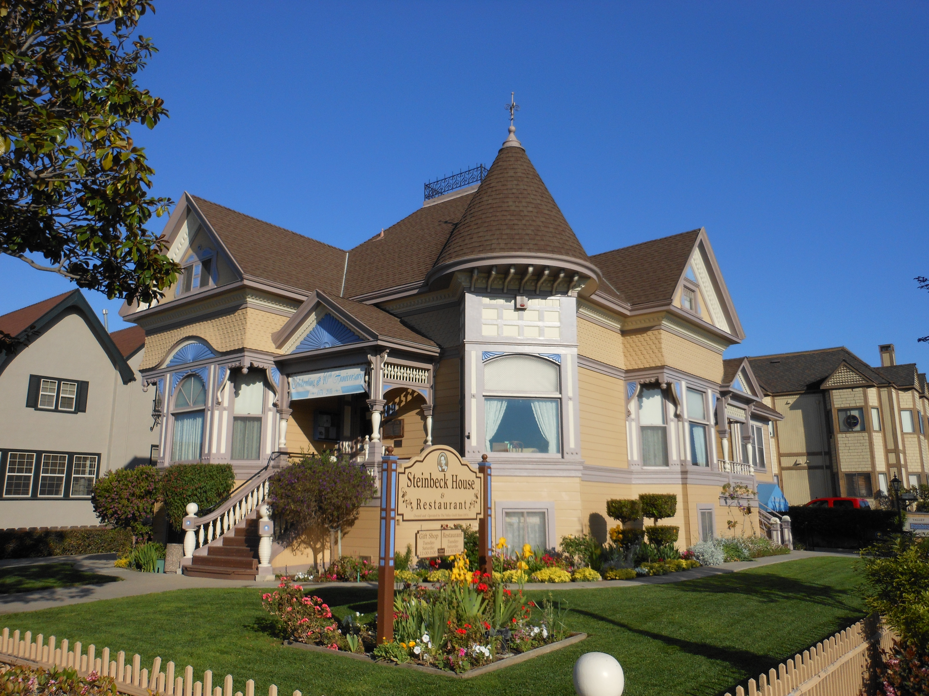  John Steinbeck House in Salinas | 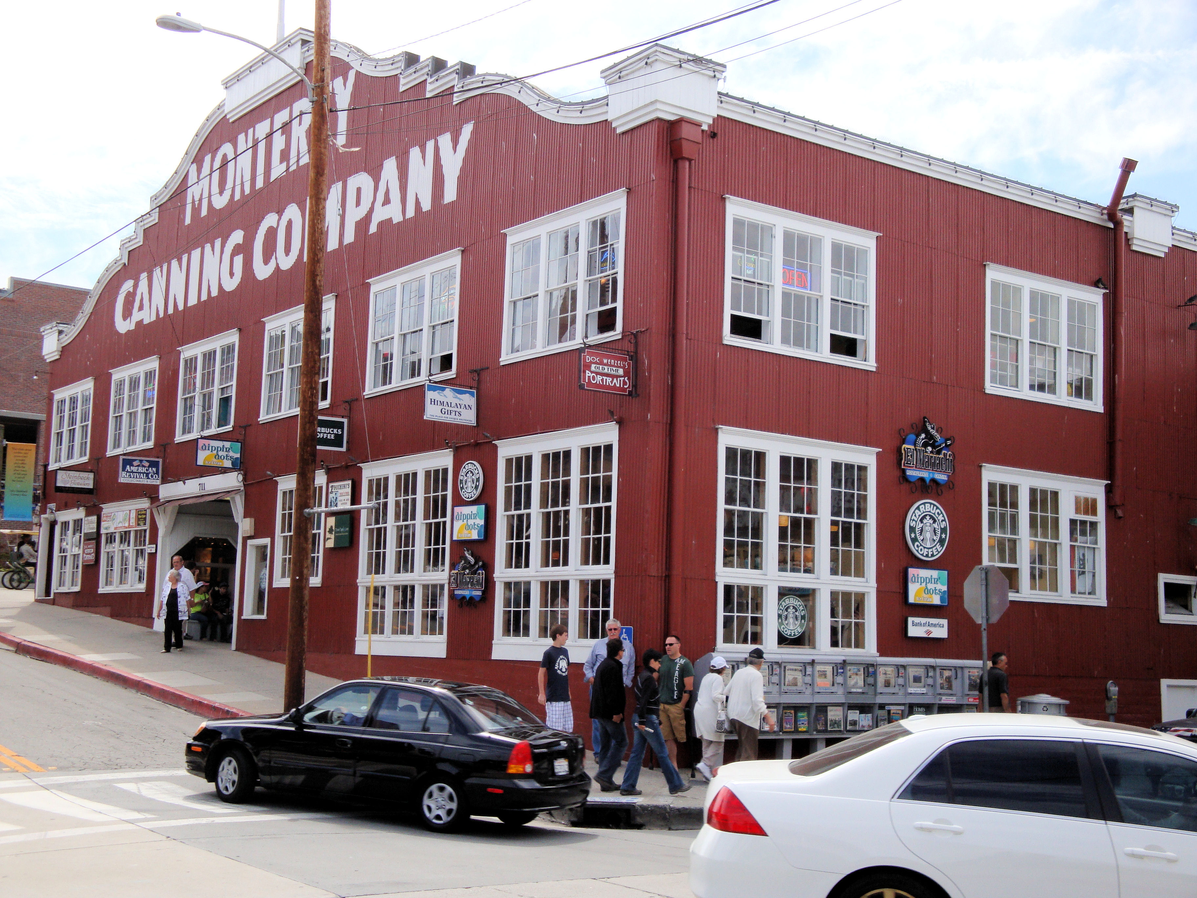  Cannery Row on Monterey's waterfront | 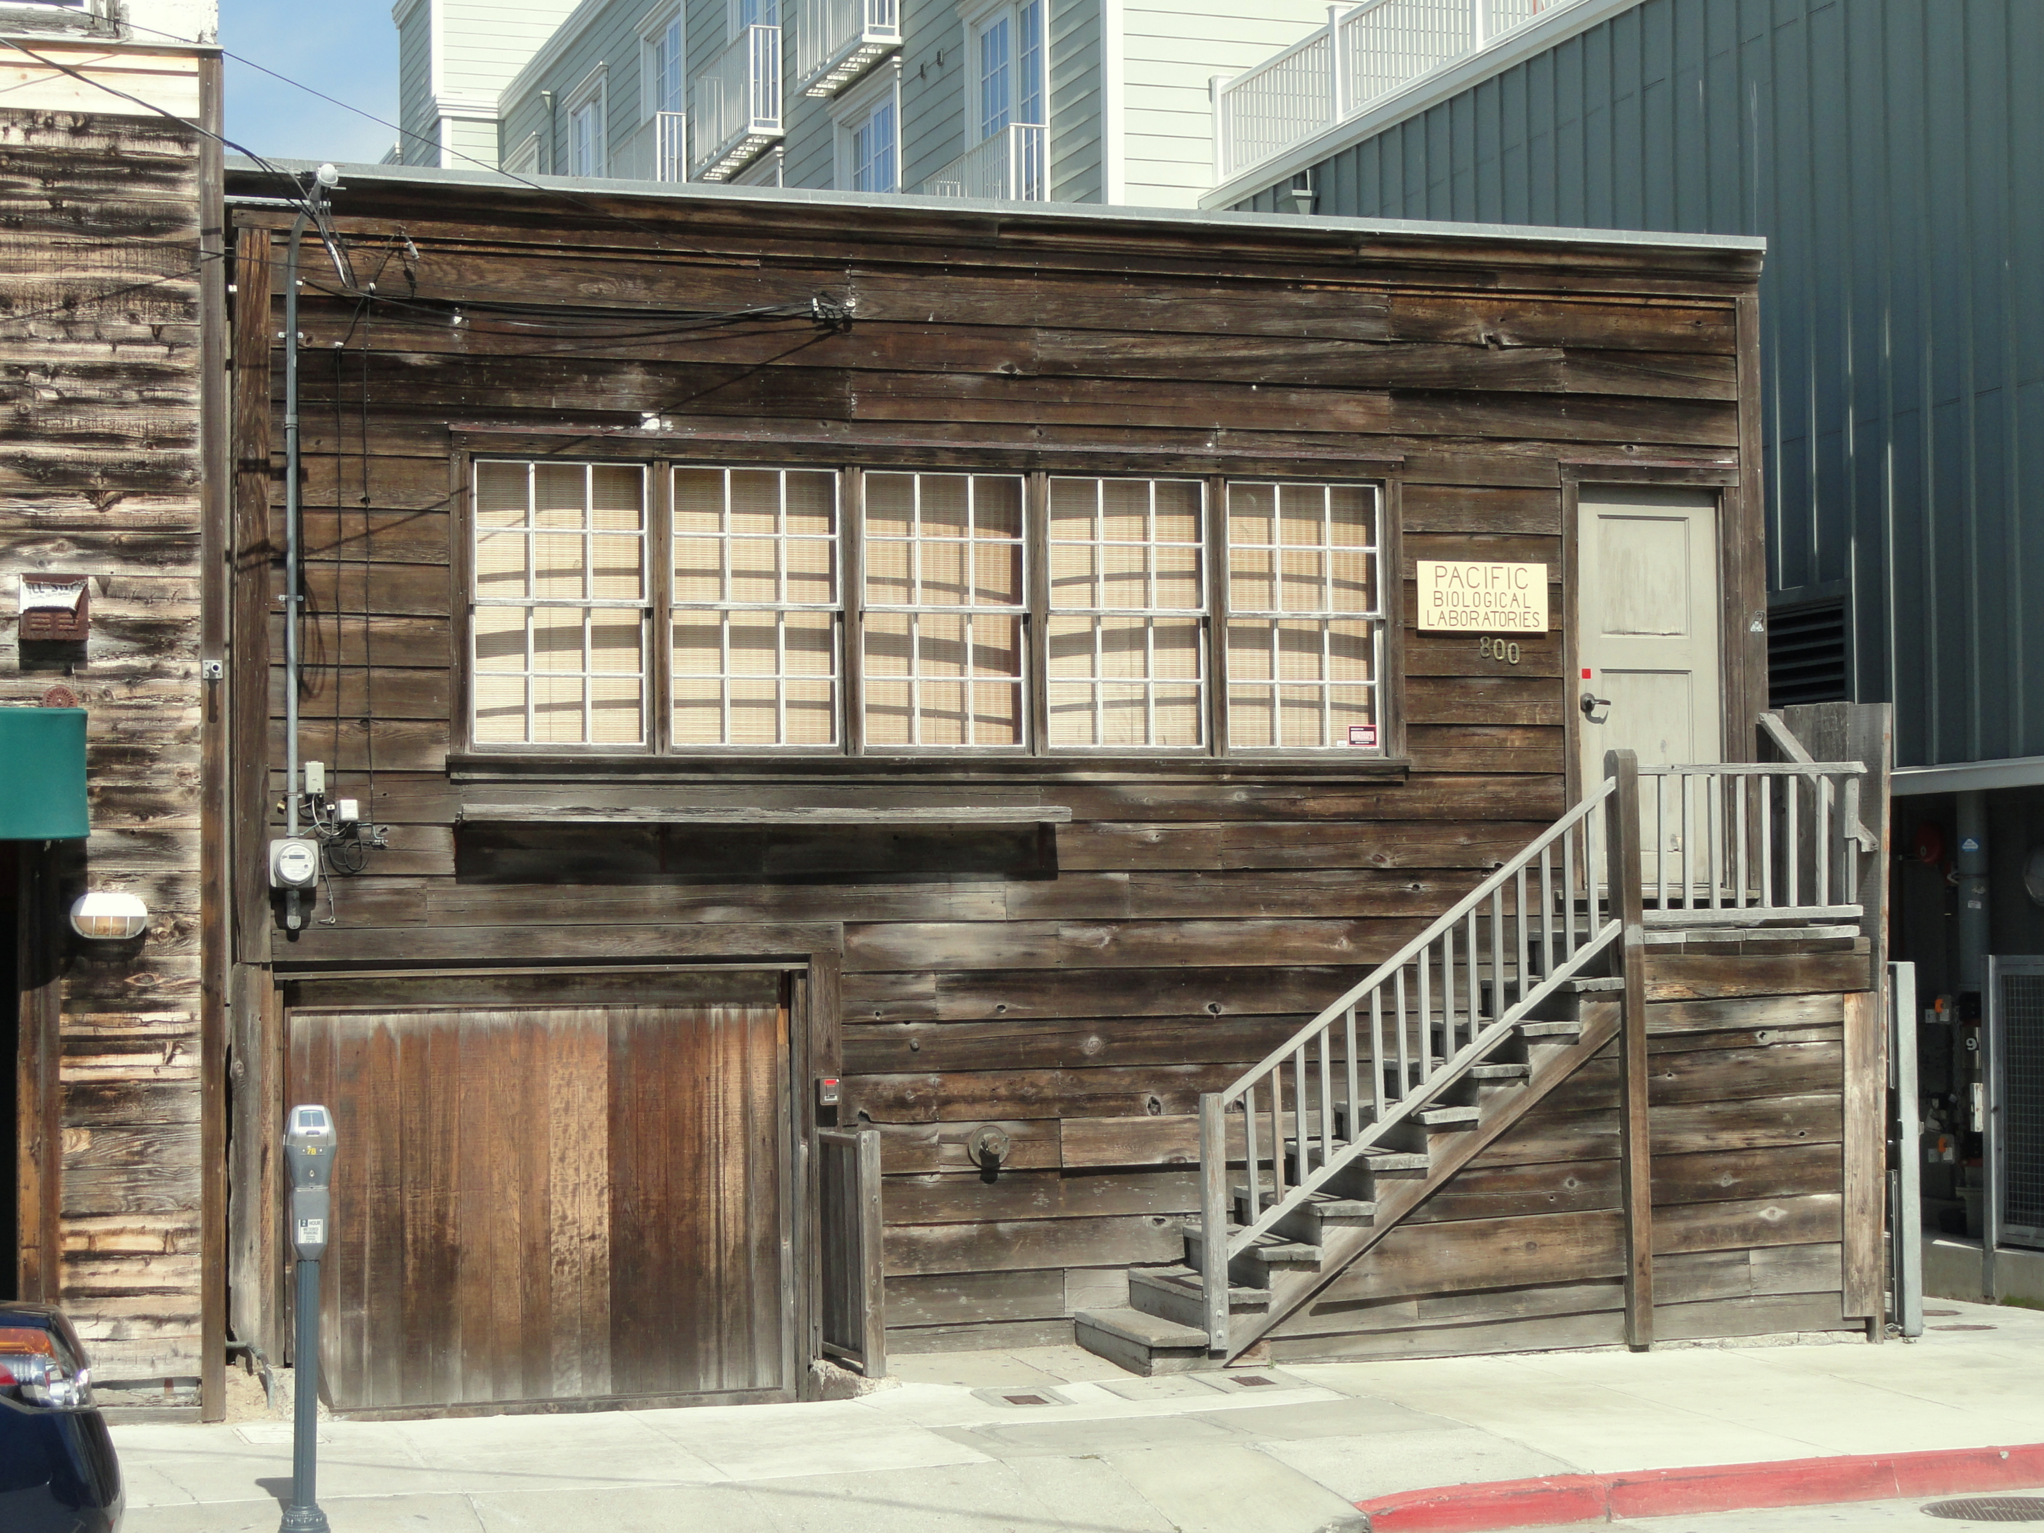  Pacific Biological Laboratories on Cannery Row

Day 2: Ricketts, Carmel, and the Tidepools
Day 2 relaxes into the marine edge: breakfast in Pacific Grove, a Carmel reset, and a long Point Lobos window that lets the trip earn its Valley to Tidepools name.
Time | Stop and context | Practical field notes
8:00 AM | Pacific Grove breakfast  Start light enough to keep the shoreline feeling open  Breakfast in Pacific Grove should feel like an opening window, not a marathon meal.  Steinbeck connection: Pacific Grove places you close to the marine edge that mattered deeply to Steinbeck's friendship and fieldwork with Ed Ricketts.  Look for: Watch how locals use the morning—dog walkers, cyclists, and people heading…  Prefer another path?: Pastry picnic at Lovers Point (45 min): It swaps table service for sea air without costing much time before the day's coastal stops.  Sources: Visit Pacific Grove; Pacific Grove Chamber of Commerce. | Address: Pacific Grove breakfast district near Central Ave and Lighthouse Ave  Primary duration: 60 minutes  Parking: Central Avenue and nearby side streets are usually manageable early, but read neighborhood restrictions before settling in.  Reservation / access: Most breakfast spots are easiest as walk-ins, though larger groups should still call if they want a specific patio or timing.  Weather / closure plan: If marine fog is thick, keep breakfast leisurely and let the shoreline reveal itself gradually instead of forcing an early rush. If one cafe is closed, use another breakfast-card option; Bookworks serves coffee before its bookstore opens.  Map: Directions to Pacific Grove breakfast
9:15 AM | Pacific Grove shoreline and Steinbeck cottage exterior context  Read the marine edge and the writer's domestic scale in one compact loop  This morning stop works best when you treat it as context rather than conquest.  Steinbeck connection: Pacific Grove joins Steinbeck's family life, his early writing years, and the near-at-hand marine world that also…  Look for: Tide line, kelp scent, and the modest size of neighborhood houses—the combination is the whole point.  Prefer another path?: Ocean View Boulevard bench-and-birdwatch loop (50 min): Non-literary travelers still get the peninsula's best morning shoreline…  Sources: City of Pacific Grove; VoiceMap Monterey Peninsula Tour. | Address: 147 11th Street and Ocean View Blvd, Pacific Grove, CA 93950  Primary duration: 60 minutes  Parking: Use legal shoreline turnouts for the water view and treat the cottage as a slow exterior pass, not a long curbside stop.  Reservation / access: No reservations; the only rule is courtesy around private homes and flexibility if the shoreline weather is rough.  Weather / closure plan: If wind is fierce, turn this into a mostly drive-through stop and save the longer outdoor walk for Point Lobos trails. If shoreline access is closed, stay on open public streets; the cottage is always exterior-only private property.  Map: Directions to Pacific Grove shoreline and Steinbeck cottage exterior context
10:45 AM | Carmel-by-the-Sea  Shift from working coast to storybook village without losing the day's momentum  Carmel gives the itinerary a tonal pivot.  Steinbeck connection: Carmel is less central to Steinbeck than Salinas or Cannery Row, but it expands the peninsula setting shared by…  Look for: Courtyards, side lanes, and the short downhill pull of Ocean Avenue toward the beach.  Prefer another path?: Carmel Beach and Ocean Avenue loop (75 min): It keeps the same geography for travelers who would rather do…  Sources: Carmel-by-the-Sea; Carmel-by-the-Sea. | Address: Carmel Plaza / Ocean Avenue, Carmel-by-the-Sea, CA 93921  Primary duration: 75 minutes  Parking: Village parking is easier before lunch; once you find a legal spot, do the town entirely on foot.  Reservation / access: No reservation for the stroll, but lunch reservations are wise if you want a specific patio after Point Lobos.  Weather / closure plan: If the village is wet or crowded, shorten the browse and shift more time to a lunch table or to the reserve. If a courtyard or beach approach is closed, use the open village streets and do not bypass barriers.  Map: Directions to Carmel-by-the-Sea
12:30 PM | Point Lobos State Natural Reserve  Give the tidepools and headlands the prime daylight window  Point Lobos is the hero moment of Day 2, so protect it from schedule drift.  Steinbeck connection: Point Lobos is not a single Steinbeck set piece, but it embodies the marine observation central to his work with…  Look for: Tidepool life, cypress silhouettes, and how quickly the reserve moves from open viewpoint to intimate cove.  Prefer another path?: Carmel River State Beach or Mission Trail nature walk (120 min): It offers a lower-effort coastal nature experience if the reserve parking…  Sources: California State Parks; Point Lobos Foundation. | Address: Point Lobos State Natural Reserve, Carmel-by-the-Sea, CA 93923  Primary duration: 150 minutes  Parking: State Parks advises early arrival because interior lots fill quickly; when the gate closes, outside parking becomes limited and safety-sensitive.  Reservation / access: No timed entry is guaranteed here, so the reservation strategy is really an arrival strategy: go early and check same-day alerts before you leave town.  Weather / closure plan: If fog closes in, embrace the near details—lichen, wave sound, cypress bark—instead of waiting for a big panoramic reveal. If the reserve is closed or parking is full, use Carmel River State Beach or Mission Trail only if locally open and safe; never park on an unsafe highway shoulder.  Map: Directions to Point Lobos State Natural Reserve
3:00 PM | Carmel lunch  Come back from the reserve hungry enough to enjoy town, not rush through it  A late Carmel lunch is one of the trip's nicest structural decisions because it turns Point Lobos into the emotional center of the day, then gives you a soft landing afterward.  Steinbeck connection: The literary connection here is indirect, but the meal preserves the route's place-based pacing: observe deeply,…  Look for: Post-hike appetite clarity—the best lunch choice is usually obvious once you…  Prefer another path?: Devendorf Park picnic with bakery provisions (60 min): It keeps you in Carmel while trading table service for speed and flexibility.  Sources: Carmel-by-the-Sea; Carmel-by-the-Sea. | Address: Carmel-by-the-Sea dining district, Carmel, CA 93921  Primary duration: 75 minutes  Parking: If you parked before Point Lobos and returned early enough, consider keeping the same village area so you do not waste energy re-hunting a spot.  Reservation / access: Popular Carmel patios and bistros can fill even mid-afternoon, so book ahead if one place matters to you.  Weather / closure plan: If everyone is chilled from the reserve, choose soup, coffee, and a sheltered interior over the prettiest outdoor patio. If a kitchen is closed or full, use another lunch-card choice with continuous afternoon service.  Map: Directions to Carmel lunch
5:00 PM | Optional final meal or road snack  Give yourselves one last peninsula choice before the long northbound slide  This final slot is intentionally flexible.  Steinbeck connection: The connection is tonal rather than textual: the trip ends with practical human needs back in view, which is…  Look for: Check traffic before you decide—sometimes the smartest souvenir is simply leaving with food already in hand.  Prefer another path?: Skip the stop and leave with filled water bottles (15 min): Some travelers will prefer the cleanest possible departure over squeezing in one last peninsula errand.  Sources: Carmel-by-the-Sea; See Monterey. | Address: Carmel or Monterey takeaway stop before departure  Primary duration: 30 minutes  Parking: Favor the easiest pickup location over the most coveted table; this stop is about departure efficiency as much as pleasure.  Reservation / access: No reservation if you keep it snack-focused; reserve only if you intentionally want a final sit-down dinner before the drive.  Weather / closure plan: If the coast turns cold, pack food for the car and begin the drive while everyone is still content. If your pickup stop is closed, use another departure-card choice or leave with water and an earlier snack.  Map: Directions to Optional final meal or road snack
6:30 PM | Selig Farm  Make the personal stop part of the northbound return rather than a separate detour day  Selig Farm is the final personal waypoint on the drive back north.  Steinbeck connection: This is a personal route stop rather than a Steinbeck site, but its working-land setting provides a quiet final…  Look for: The shift from exposed coastline back into the cultivated foothills around Watsonville.  Prefer another path?: Continue north without the private stop (15 min): It is the right fallback if timing, access, or host availability changes.  Sources: Traveler-provided destination. | Address: 434 Old Smith Road, Watsonville, CA 95076  Primary duration: 45 minutes  Parking: Follow the host's directions and keep gates, lanes, and working access clear.  Reservation / access: Private property; arrange permission and arrival timing directly with the host before visiting.  Weather / closure plan: If coastal traffic or weather pushes the schedule late, contact the host and shorten or skip the stop rather than arriving unexpectedly.  Map: Directions to Selig Farm

Day 2 closing coastal module
Key coast read: Pacific Grove, Carmel, and Point Lobos should feel like a connected shoreline sequence rather than separate errands. Use this closing strip to keep the return leg anchored in the trip's final shoreline mood.
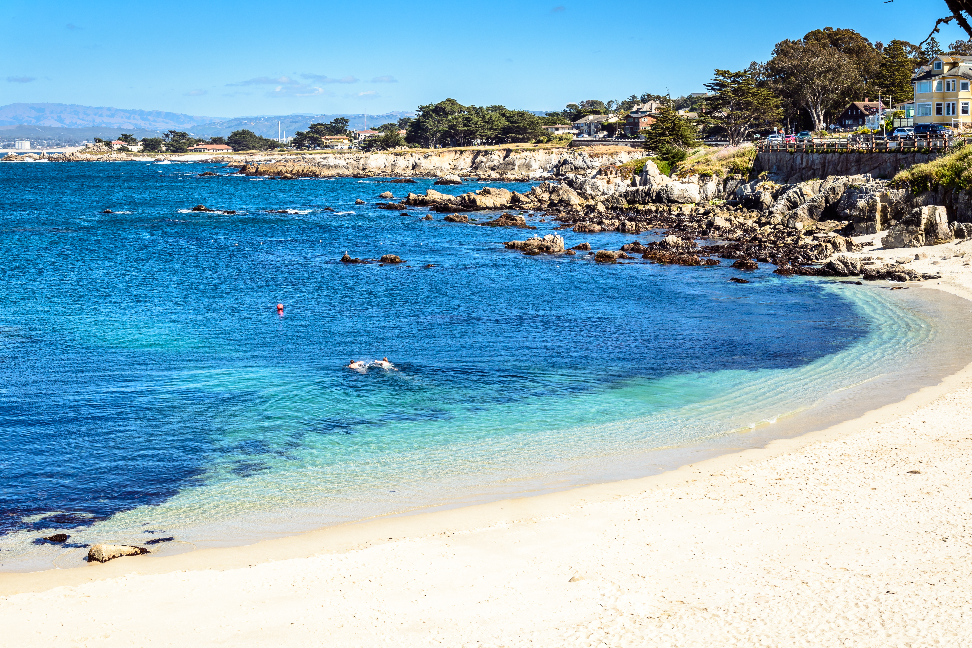  Lovers Point shoreline in Pacific Grove | 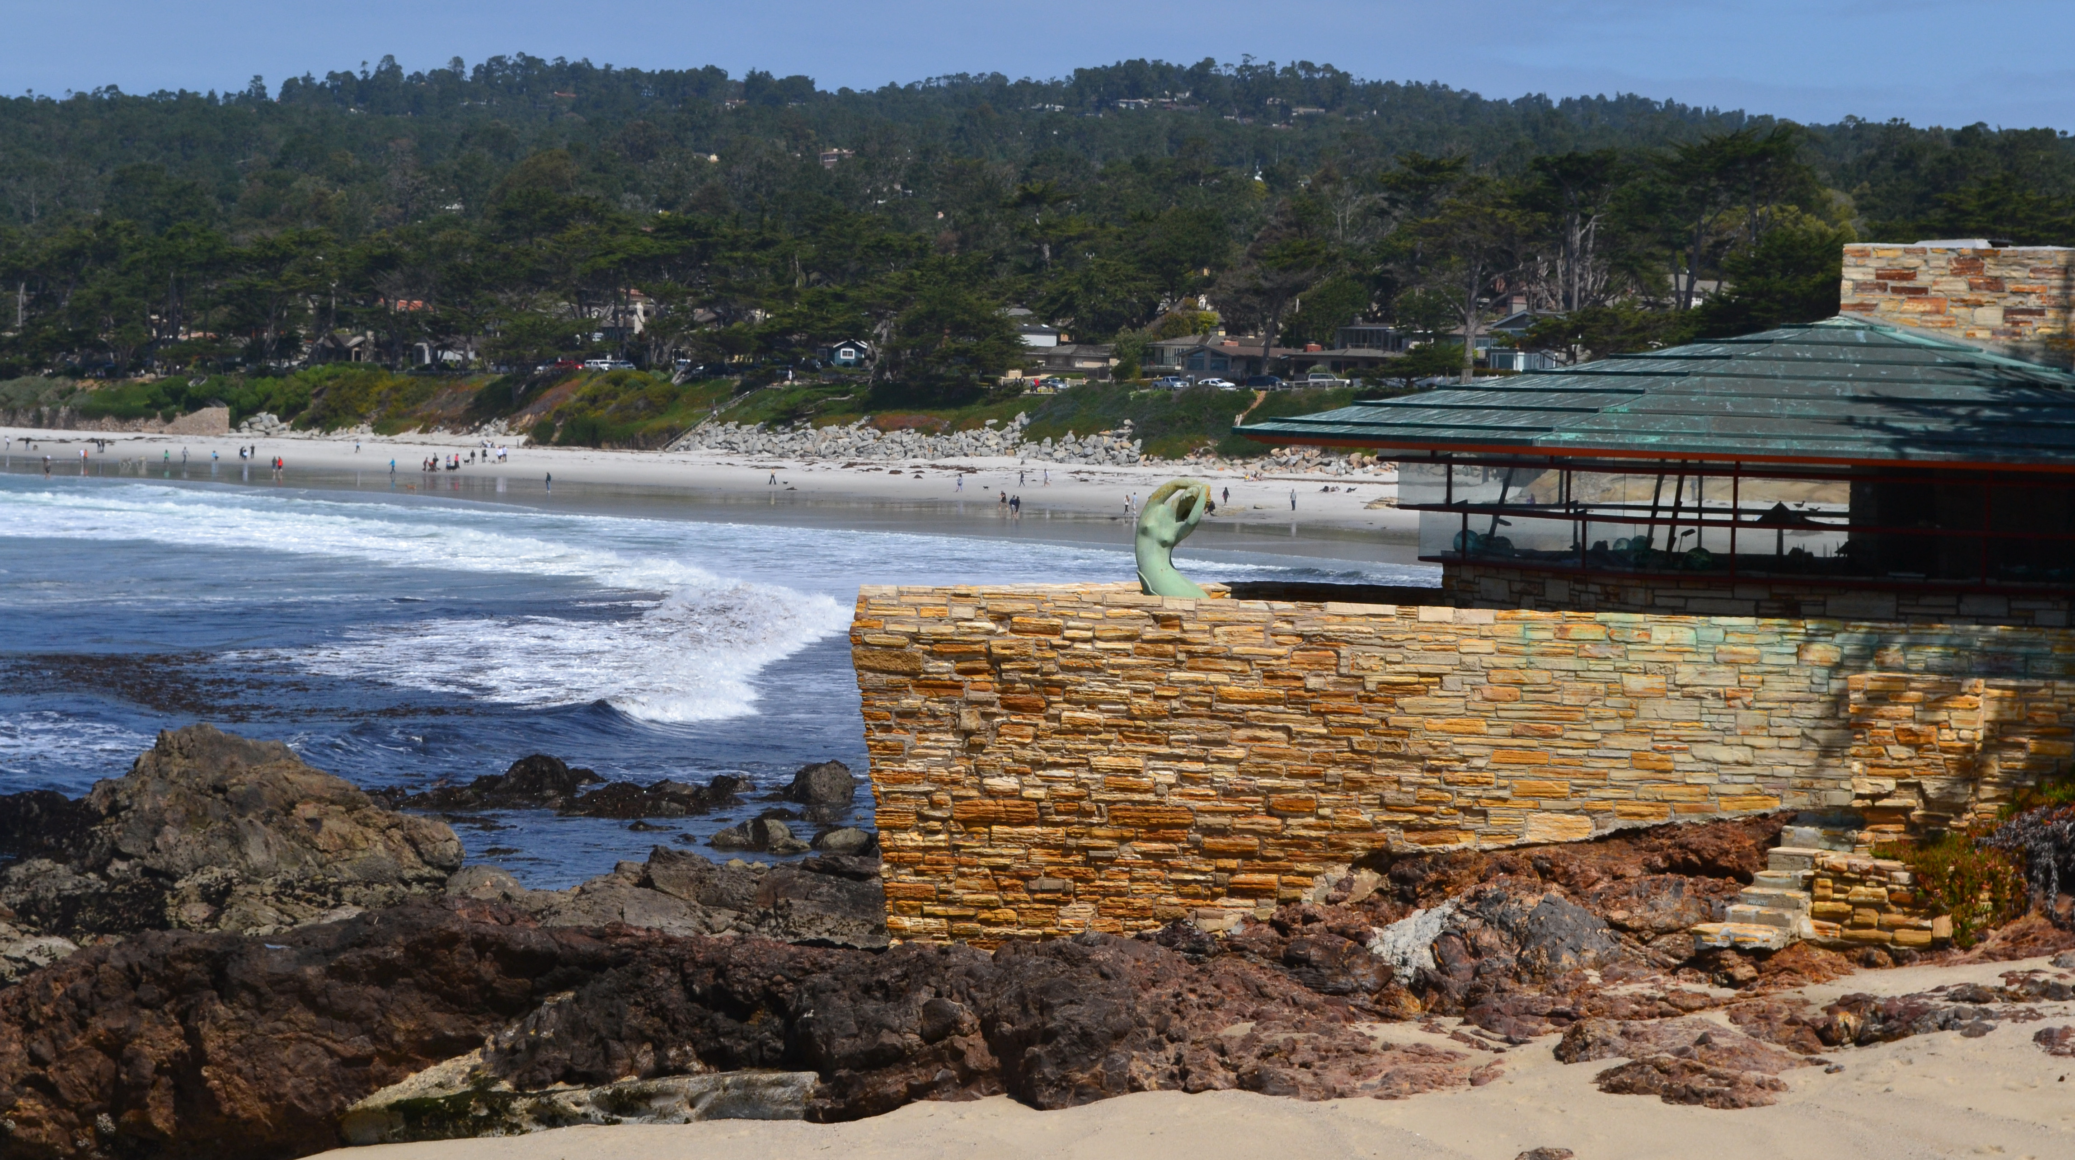  Mrs. Clinton Walker House in Carmel-by-the-Sea | 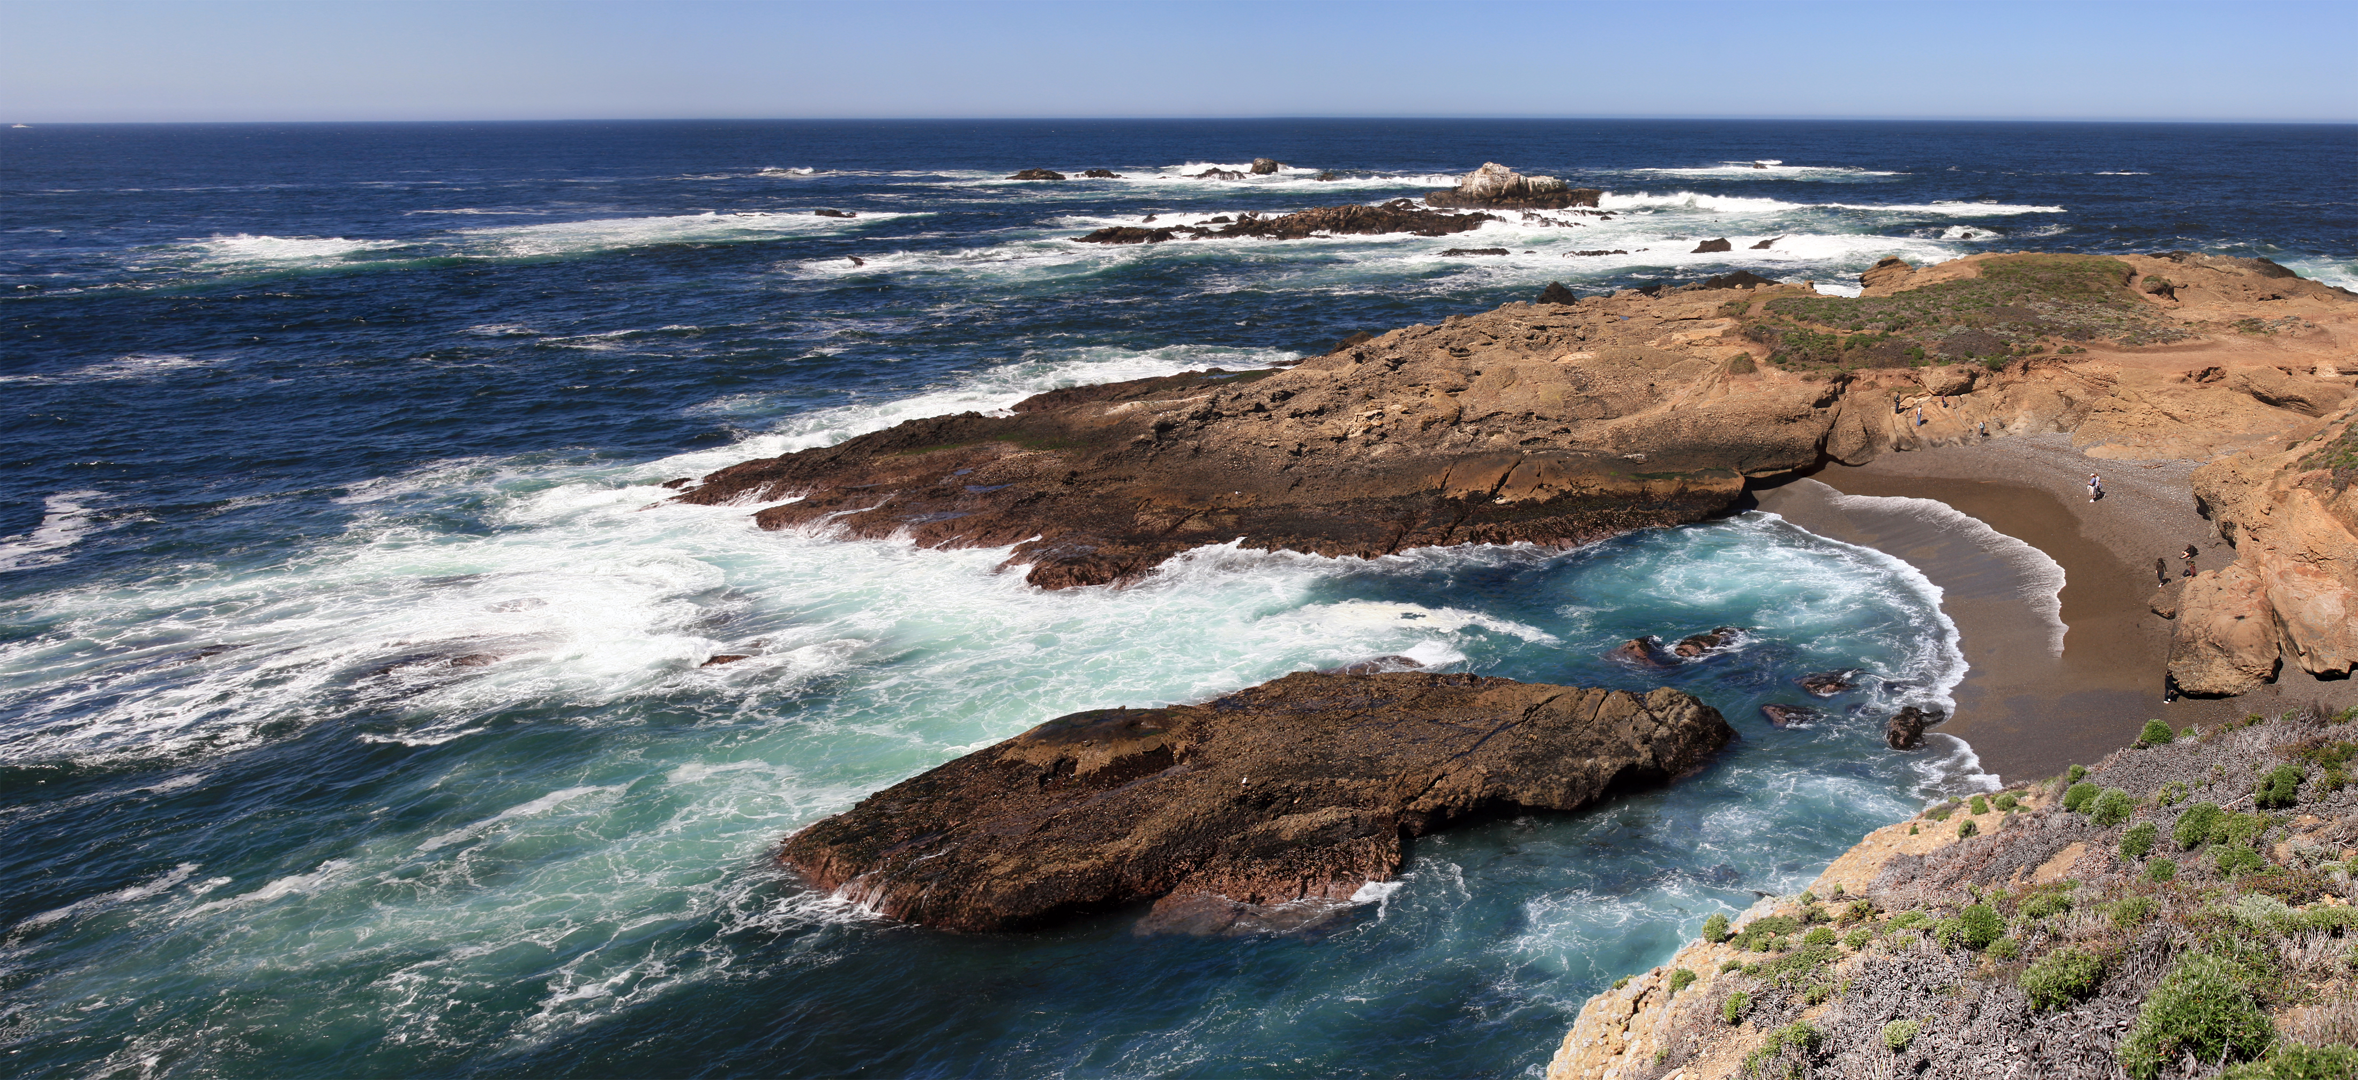  Point Lobos headlands and cypress | 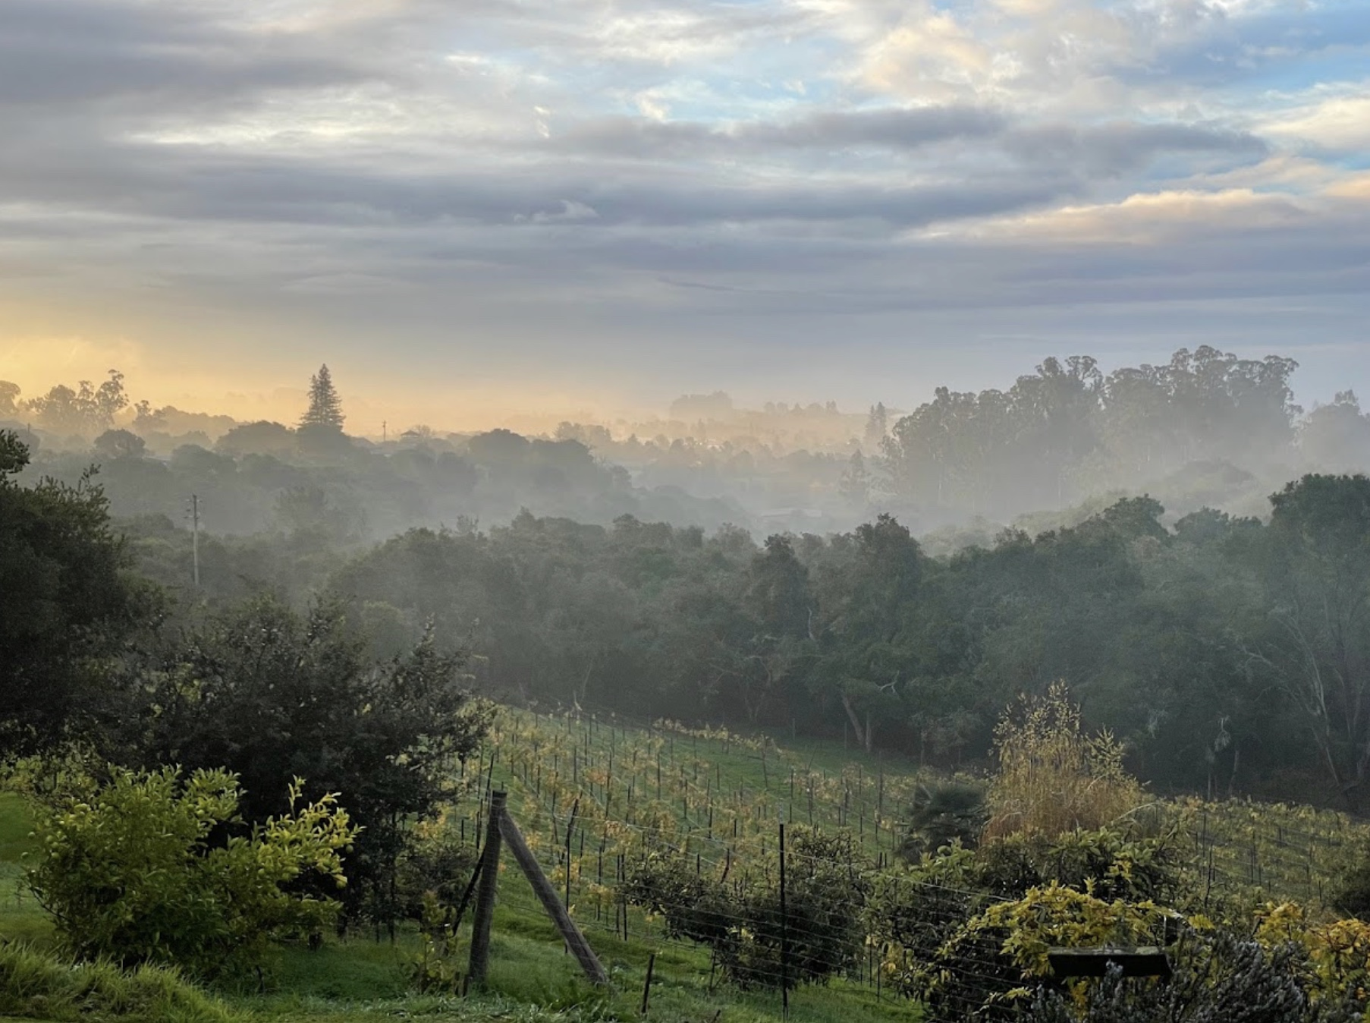  Morning mist over Selig Farm

Six meal cards
Choose for your service day as well as appetite. Julia's Vegetarian gives Day 1 dinner a local, plant-forward finish; each card keeps three distinct choices. Hours are dated, not a guarantee: reconfirm holidays and last orders.
Day 1 coffee and first stretch — Moss Landing / Castroville  Around 9:45 AM  1. Power Plant Coffee  Moss Landing · Coffee, breakfast, pies · $  Location: 7990 Highway 1, Moss Landing, CA 95039  Route distance / fit: Directly on route  Why it fits: Officially advertises coffee, pies, and an all-day breakfast menu, making it the cleanest route-first stop.  Service days / hours: Sunday-Friday 7 AM-4 PM; Saturday 7 AM-5 PM. All-day breakfast; reconfirm holidays.  Reservation / ordering: Walk-in only; verify same-day hours if timing is tight.  Official site: Visit Power Plant Coffee website  2. Moss Landing Cafe  Moss Landing · American breakfast and coastal diner · $  Location: 421 Moss Landing Road, Moss Landing, CA 95039  Route distance / fit: Short village detour from Highway 1; return to Highway 156 for Salinas.  Why it fits: A well-reviewed sit-down breakfast with eggs, pancakes, and seafood scrambles, open well before the 9:45 AM stop.  Service days / hours: Daily 7 AM-2:30 PM per the corroborating listing; no regular closed weekday listed.  Reservation / ordering: Walk-in; call (831) 633-3355 to reconfirm holiday service.  Independent restaurant listing: Read Moss Landing Cafe listing  3. La Fortuna Bakery  Castroville · Pan dulce, breakfast burritos, and tamales · $  Location: 11286 Merritt Street, Castroville, CA 95012  Route distance / fit: Brief Merritt Street stop in Castroville on the Moss Landing-to-Salinas leg via Highway 156.  Why it fits: A well-reviewed quick breakfast bakery on the southbound approach to Salinas, rather than a seafood kitchen that opens after breakfast.  Service days / hours: Daily 5 AM-8 PM per the corroborating listing; no regular closed weekday listed.  Reservation / ordering: Counter service; call (831) 632-0411 to reconfirm holiday hours.  Independent restaurant listing: Read La Fortuna Bakery listing | Day 1 lunch — Salinas  Around 1:15 PM  1. The Steinbeck House  Salinas · Historic lunch restaurant · $$  Location: 132 Central Avenue, Salinas, CA 93901  Route distance / fit: Directly on route  Why it fits: It extends the literary mood most elegantly and keeps lunch inside the key Day 1 geography.  Service days / hours: Lunch Tuesday-Saturday 11:30 AM-2 PM; closed for regular lunch Sunday and Monday. Special events may replace service.  Reservation / ordering: Call (831) 424-2735 ahead; arrive at 1:15 PM and order before lunch service ends at 2 PM.  Official site: Visit The Steinbeck House website  2. Alvarado Street Brewery Taproom  Salinas · Family-friendly pub fare and craft beer · $$  Location: 301 Main Street, Salinas, CA 93901 — Oldtown taproom, not the Dayton Street production brewery.  Route distance / fit: About a few downtown blocks south of the Steinbeck Center; walk rather than move the car.  Why it fits: A well-reviewed Oldtown lunch in a former bank, with burgers, pizzas, and tacos that keep the museum-to-house sequence walkable.  Service days / hours: Tuesday-Thursday noon-10 PM; Friday-Saturday noon-11 PM; Sunday noon-9 PM; closed Monday.  Reservation / ordering: Walk-ins welcomed for 1-10 guests; limited online reservations. Confirm larger groups directly.  Official site: Visit Alvarado Street Brewery Taproom website  3. First Awakenings  Salinas · Casual American breakfast-and-lunch café · $$  Location: 171 Main Street, Salinas, CA 93901  Route distance / fit: Walkable from the Steinbeck Center  Why it fits: A quick, familiar Oldtown lunch if you arrive as planned; choose a different venue if you cannot order before 2 PM.  Service days / hours: Daily 7 AM-2 PM per the corroborating listing; no regular closed weekday listed. Do not drift past 2 PM.  Reservation / ordering: Walk-in; at 1:15 PM allow a quick lunch and order before the 2 PM close. Call (831) 784-1125 if delayed.  Independent restaurant listing: Read First Awakenings listing
Day 1 dinner — Monterey / Pacific Grove  Around 7:00 PM  1. Julia's Vegetarian  Pacific Grove · Vegetarian and vegan California comfort food · $$  Location: 1180 Forest Avenue, Suite F, Pacific Grove, CA 93950  Route distance / fit: Short drive from Cannery Row  Why it fits: It is distinctive, local, and close enough to Cannery Row to keep dinner easy after a full literary day.  Service days / hours: Open every day 8:58 AM-9:02 PM; lunch and dinner from 1 PM to close.  Reservation / ordering: Dinner reservations are wise on busy nights; call if you want live-music timing.  Official site: Visit Julia's Vegetarian website  2. Passionfish  Pacific Grove · Seafood and sustainable California fare · $$$  Location: 701 Lighthouse Avenue, Pacific Grove, CA 93950  Route distance / fit: Short drive from Cannery Row  Why it fits: Ideal if the group wants a classic peninsula seafood dinner with a short return to lodging.  Service days / hours: Dinner nightly from 5 PM; confirm your 7 PM reservation and holiday closing time directly.  Reservation / ordering: Reserve ahead, especially on weekends.  Official site: Visit Passionfish website  3. Fish Hopper  Monterey · Cannery Row seafood · $$$  Location: 700 Cannery Row, Monterey, CA 93940 — Waterfront restaurant on Cannery Row.  Route distance / fit: Already on route  Why it fits: The easiest no-extra-driving choice if you would rather stay on the Row and watch evening foot traffic.  Service days / hours: Daily 10:30 AM-9 PM; reconfirm holiday service and view-table availability.  Reservation / ordering: Reserve if you want a view table at prime time.  Official site: Visit Fish Hopper website | Day 2 breakfast — Pacific Grove / Monterey  Around 8:00 AM  1. Red House Cafe  Pacific Grove · Neighborhood breakfast and brunch · $$  Location: 662 Lighthouse Avenue, Pacific Grove, CA 93950  Route distance / fit: Short hop to the shoreline  Why it fits: A classic cozy start that still keeps you close to Lovers Point and Ocean View Boulevard.  Service days / hours: Tuesday-Saturday 8 AM-9 PM; Sunday-Monday 8 AM-2:30 PM. Arrive at opening for the 8 AM slot.  Reservation / ordering: Walk-in is the default; go early for the easiest seating.  Official site: Visit Red House Cafe website  2. First Awakenings  Monterey · Hearty American breakfast · $$  Location: 300 David Avenue, Monterey, CA 93940 — Current Monterey location, relocated from its former Pacific Grove site.  Route distance / fit: New Monterey near Cannery Row; a short drive back to the Pacific Grove shoreline loop.  Why it fits: Best if the group wants substantial breakfast fuel before Point Lobos.  Service days / hours: Daily 7 AM-2 PM per the current corroborating hours listing; confirm any later weekend closing directly. Breakfast and lunch daily.  Reservation / ordering: Usually easiest as an early walk-in.  Corroborating listing (Lighthouse District; not an official site): Read First Awakenings listing  3. Bookworks  Pacific Grove · Bookstore café and bakery · $  Location: 667 Lighthouse Avenue, Pacific Grove, CA 93950  Route distance / fit: Short hop to shoreline loop  Why it fits: A lighter, literary-adjacent breakfast if you want coffee and pastry before a shoreline walk.  Service days / hours: Coffee shop daily 7 AM-5:30 PM; bookstore opens at 9:30 AM, so the 8 AM stop is cafe-only.  Reservation / ordering: Walk-in only makes the stop fast.  Official site: Visit Bookworks website
Day 2 lunch — Carmel-by-the-Sea  Around 3:00 PM  1. La Bicyclette  Carmel-by-the-Sea · European country bistro · $$$  Location: Dolores Street at 7th Avenue, Carmel-by-the-Sea, CA 93921  Route distance / fit: Already in Carmel core  Why it fits: One of the most atmospheric choices if you want Carmel charm to feel fully earned after Point Lobos.  Service days / hours: Lunch and dinner daily 11 AM-9 PM, with continuous afternoon service.  Reservation / ordering: Reserve if it matters; Carmel lunch rooms fill quickly on weekends.  Official site: Visit La Bicyclette website  2. Carmel Belle  Carmel-by-the-Sea · Casual market-driven café · $$  Location: Ocean Avenue at San Carlos Street, Carmel-by-the-Sea, CA 93921 — Inside Doud Craft Studios.  Route distance / fit: Already in Carmel core  Why it fits: Great when you want something fresh and fast enough to keep the afternoon flexible.  Service days / hours: Daily 8 AM-5:30 PM; 3 PM is within afternoon service, not at closing.  Reservation / ordering: Usually best as a walk-in.  Official site: Visit Carmel Belle website  3. Il Fornaio Carmel  Carmel-by-the-Sea · Italian pasta, pizza, and seasonal dishes · $$$  Location: Pine Inn, Ocean Avenue at Monte Verde Street, Carmel-by-the-Sea, CA 93921  Route distance / fit: Already in Carmel core  Why it fits: A well-reviewed village restaurant with continuous afternoon service, so the 3 PM arrival does not collide with a lunch closing time.  Service days / hours: Monday-Thursday 11:30 AM-9 PM; Friday 11:30 AM-9:30 PM; Saturday 7:30 AM-9:30 PM; Sunday 7:30 AM-9 PM.  Reservation / ordering: Reserve online or call (831) 622-5100, especially for a specific indoor or patio table.  Official site: Visit Il Fornaio Carmel website  4. Nepenthe  Big Sur · California coastal dining · $$$  Location: 48510 Highway 1, Big Sur, CA 93920  Route distance / fit: Optional extension south of Point Lobos; allow roughly 80-100 extra minutes of round-trip driving before wait and meal time.  Why it fits: The terrace and high Pacific view make this the most memorable meal option if you are willing to turn Day 2 into a longer Big Sur excursion.  Service days / hours: Open daily from 11:30 AM; lunch service covers the scheduled 3 PM meal window. Confirm current hours and Highway 1 conditions before leaving Point Lobos.  Reservation / ordering: First come, first served; Nepenthe does not accept dining reservations, so arrive with time for a wait.  Official site: Visit Nepenthe website | Day 2 departure meal or road snack — Carmel / Monterey  Around 5:00 PM  1. Carmel Bakery  Carmel-by-the-Sea · Bakery, coffee, portable sweets · $  Location: Ocean Avenue between Dolores and Lincoln Streets, Carmel-by-the-Sea, CA 93921  Route distance / fit: Already in Carmel core  Why it fits: Best when you want a graceful final snack without committing to another full meal.  Service days / hours: Weekdays 7 AM-7 PM; weekends 7 AM-8 PM. Winter closing may vary with weather; call ahead.  Reservation / ordering: Walk-in takeaway; credit/debit cards only. Call for weather-dependent winter closing times.  Official site: Visit Carmel Bakery website  2. Treehouse Café  Carmel-by-the-Sea · Mediterranean and international café fare · $$  Location: San Carlos Street between 7th and 8th Avenues, Carmel-by-the-Sea, CA 93921  Route distance / fit: Already in Carmel core  Why it fits: Useful if you decide you do want one more proper meal before the drive north.  Service days / hours: Daily 11 AM-9 PM; 5 PM early dinner is within regular service.  Reservation / ordering: Call ahead if you want a guaranteed table at a specific hour.  Official site: Visit Treehouse Café website  3. Rosine's Restaurant  Monterey · Classic American comfort food and desserts · $$  Location: 434 Alvarado Street, Monterey, CA 93940 — Downtown restaurant, not the separate Sand City Caffe.  Route distance / fit: Short detour on the way out  Why it fits: A solid fallback if traffic, appetite, or weather pulls you back toward Monterey before departure.  Service days / hours: Restaurant open daily 8 AM-9 PM; hours subject to change. The separate Sand City Caffe has different hours.  Reservation / ordering: Walk-ins are common, but check same-day wait times if you hit downtown at peak dinner hour.  Official site: Visit Rosine's Restaurant website

Planning and reservation checklist
Last verified: October 5, 2026. Reconfirm hours, closures, and reservation rules one week before departure, then again the night before Day 1.

Reservations to lock
- National Steinbeck Center is easiest to confirm on its official visit page, especially around holidays and special closures.
- Steinbeck House lunch (Tuesday-Saturday) and dated house tours need a current-calendar check and advance call.
- Point Lobos rewards early arrival more than any other stop on the trip; parking logistics effectively function as a reservation system.
- Dinner and lodging should be booked ahead for Friday/Saturday travel dates.
- Nepenthe is first come, first served; check Highway 1 conditions and allow time for a wait before committing to the Big Sur extension.

Parking and access reminders
- Downtown Salinas is easiest with the garage near the Steinbeck Center plus short walks between stops.
- Cannery Row is best handled by parking once and walking the district rather than moving the car for every marker.
- Point Lobos forbids dogs, collecting, smoking, and after-hours lingering; treat it as a protected landscape, not a casual turnout.

Weather adjustments
- Morning fog can make Day 2 feel flat at first, but it often burns off enough for a stronger Point Lobos window later on.
- If rain settles in, lean harder on the National Steinbeck Center, Carmel's indoor cafés, and a cozy historic inn rather than fighting for viewpoints.
- Layering matters more than temperatures suggest because wind exposure rises sharply at shoreline stops.

What to pack
- Comfortable walking shoes with decent traction for Point Lobos.
- Layers for fog, sun, and evening wind.
- Water, sunscreen, and a small day bag so Cannery Row and Carmel remain easy on foot.
- A printed or saved note with key reservation numbers in case service is patchy.

Editable prompts before you leave
- Set Day 1 Tuesday-Saturday for all three Salinas lunch choices; on Monday only First Awakenings has regular service, and Sunday excludes Steinbeck House lunch.
- Treat Nepenthe as an optional Big Sur extension, not part of the default Carmel timing.
- Confirm current hours one week before departure, then again the night before Day 1.

Reading list
Use the books as primers, companions, or debriefs. The pairings below keep each title tied to a physical stop or mood from the trip instead of treating the reading as homework.
Title | Why now | Trip connection
East of Eden | Best for seeing the Salinas Valley as moral and familial landscape, not just scenery. | Pairs with the National Steinbeck Center and the field-edge stop.
Cannery Row | The clearest literary companion for the Monterey waterfront and the Ricketts circle. | Best read before the Cannery Row walk and Pacific Biological Laboratories stop.
The Log from the Sea of Cortez | Deepens the ecological thread linking Steinbeck, Ricketts, and Day 2's marine observations. | Pairs naturally with Point Lobos and the Pacific Grove shoreline.
The Red Pony | A shorter way to feel the rural emotional climate of the Salinas Valley if you want a compact pre-trip read. | Works especially well for the transition from city departure to agricultural landscape.

Sources and image credits
This final section keeps the guide editable without losing provenance. Every operational fact is tied back to a dated source, and every visual asset carries a reusable license note.

Research sources
Source | Verification notes
National Steinbeck Center — Plan your Visit  Source URL: Read Plan your Visit | Verified 2026-10-05. Official visit page states daily 10 AM-5 PM hours, admission guidance, and parking context.
The Steinbeck House — The Steinbeck House  Source URL: Read The Steinbeck House | Verified 2026-10-05. Official site confirms the property is Steinbeck's birthplace and a current restaurant / heritage destination.
See Monterey — The Steinbeck House  Source URL: Read The Steinbeck House | Verified 2026-10-05. Tourism listing supplies concise current lunch and gift-shop hours for practical planning.
See Monterey — Salinas Restaurants  Source URL: Read Salinas Restaurants | Verified 2026-10-05. Official regional tourism directory used for downtown Salinas meal planning.
Soul of California — The Salinas Valley  Source URL: Read The Salinas Valley | Verified 2026-10-05. Regional destination site used to support the valley-as-landscape framing when no…
The Power Plant Coffee & Store — Home  Source URL: Read Home | Verified 2026-10-05. Official published cafe text, updated July 1, 2026, states Sunday-Friday 7 AM-4…
Restaurantji — The Power Plant Coffee — address and reviews  Source URL: Read The Power Plant Coffee — address and reviews | Verified 2026-10-05. Corroborating listing, not an official venue site: names The Power Plant Coffee…
Cannery Row — In Steinbeck's Steps  Source URL: Read In Steinbeck's Steps | Verified 2026-10-05. Official district history page used for Cannery Row markers and literary context.
City of Monterey — Pacific Biological Laboratories  Source URL: Read Pacific Biological Laboratories | Verified 2026-10-05. City page: second Saturdays January-November, tours 10 AM and 11:30 AM, open…
California State Parks — Point Lobos State Natural Reserve  Source URL: Read Point Lobos State Natural Reserve | Verified 2026-10-05. Official state park page used for reserve rules, day-use framing, and visitor cautions.
Point Lobos Foundation — Visitor Information  Source URL: Read Visitor Information | Verified 2026-10-05. Foundation visitor pages corroborate planning guidance and current educational framing.
City of Pacific Grove — Shoreline  Source URL: Read Shoreline | Verified 2026-10-05. Official city page confirms the shoreline park network stretching from Hopkins Marine Station toward Asilomar.
Pacific Grove Chamber of Commerce — Tourist Information Centers  Source URL: Read Tourist Information Centers | Verified 2026-10-05. Official chamber page confirms visitor-center location and hours used for on-the-ground planning advice.
Visit Pacific Grove — Dining  Source URL: Read Dining | Verified 2026-10-05. Official tourism dining hub used for Pacific Grove breakfast and dinner option framing.
VoiceMap Monterey Peninsula Tour — Steinbeck Family Cottage 147 11th Street  Source URL: Read Steinbeck Family Cottage 147 11th Street | Verified 2026-10-05. Secondary source used only because an obvious official page for the…
Carmel-by-the-Sea — Official Travel Site  Source URL: Read Official Travel Site | Verified 2026-10-05. Official tourism homepage establishes Carmel's walkable village character.
Carmel-by-the-Sea — Visitor Center  Source URL: Read Visitor Center | Verified 2026-10-05. Official visitor-center page used for staffing and orientation guidance.
Carmel-by-the-Sea — Restaurants & Bars in Carmel-by-the-Sea  Source URL: Read Restaurants & Bars in Carmel-by-the-Sea | Verified 2026-10-05. Official restaurant directory used for Carmel lunch and departure-meal options.
Julia's Vegetarian Restaurant — Julia's Vegetarian Restaurant  Source URL: Read Julia's Vegetarian Restaurant | Verified 2026-10-05. Official page identifies 1180 Forest Ave, Suite F, Pacific Grove; open every day…
Pacific Grove Chamber of Commerce — Julia's Vegetarian Restaurant  Source URL: Read Julia's Vegetarian Restaurant | Verified 2026-10-05. Official chamber listing corroborates Julia's as a current Pacific Grove dining option.
See Monterey — Food & Drink  Source URL: Read Food & Drink | Verified 2026-10-05. Official regional tourism dining hub used for Monterey-area meal alternatives.
Nepenthe — Nepenthe  Source URL: Read Nepenthe | Verified 2026-10-07. Official site used for the Big Sur address, dining character, hours, and…
Traveler-provided destination — Selig Farm destination  Source URL: Read Selig Farm destination | Verified 2026-10-07. Name and address supplied directly by the traveler for a private return-route…
Victorian Inn Monterey — Victorian Inn  Source URL: Read Victorian Inn | Verified 2026-10-05. Official hotel page confirms Cannery Row location and historic Lang House framing.
Green Gables Inn — Green Gables Inn  Source URL: Read Green Gables Inn | Verified 2026-10-05. Official hotel page verifies the Pacific Grove ocean-view Victorian positioning.
Old St. Angela Inn — Old St. Angela Inn  Source URL: Read Old St. Angela Inn | Verified 2026-10-05. Official hotel URL corroborated via tourism research; direct page fetch was access-limited during this task.
Restaurantji — Moss Landing Cafe — breakfast, hours, and reviews  Source URL: Read Moss Landing Cafe — breakfast, hours, and reviews | Verified 2026-10-05. Corroborating listing, not an official venue site: 421 Moss Landing Road, daily 7…
Restaurantji — La Fortuna Bakery — breakfast, hours, and reviews  Source URL: Read La Fortuna Bakery — breakfast, hours, and reviews | Verified 2026-10-05. Corroborating listing, not an official venue site: 11286 Merritt Street,…
Alvarado Street Brewery — Oldtown Salinas Taproom — location, hours, and food  Source URL: Read Oldtown Salinas Taproom — location, hours, and food | Verified 2026-10-05. Official page identifies the Oldtown taproom at 301 Main Street, Salinas, serving…
OpenTable (indexed corroboration) — Oldtown Salinas Taproom — indexed diner reviews  Source URL: Read Oldtown Salinas Taproom — indexed diner reviews | Verified 2026-10-05. Indexed OpenTable page identifies the Salinas taproom and reports 4.6/5 from 96 reviews.
Restaurantji — First Awakenings Salinas — location and hours  Source URL: Read First Awakenings Salinas — location and hours | Verified 2026-10-05. Corroborating listing, not an official venue site: 171 Main Street, Salinas,…
New Monterey Business Association / Lighthouse District — First Awakenings Monterey — relocated breakfast venue  Source URL: Read First Awakenings Monterey — relocated breakfast venue | Verified 2026-10-05. Corroborating business-association listing identifies 300 David Avenue, Monterey,…
Restaurantji — First Awakenings Monterey — corroborating hours  Source URL: Read First Awakenings Monterey — corroborating hours | Verified 2026-10-05. Despite its legacy Pacific Grove URL path, actual final page content identifies…
Passionfish — Passionfish  Source URL: Read Passionfish | Verified 2026-10-05. Official page identifies Passionfish at 701 Lighthouse Ave, Pacific Grove, with dinner nightly from 5 PM.
Restaurantji — Passionfish — corroborating closing hours  Source URL: Read Passionfish — corroborating closing hours | Verified 2026-10-05. Corroborating business-hours section identifies 701 Lighthouse Ave, Pacific Grove, with daily 5-9 PM service.
Fish Hopper — Fish Hopper  Source URL: Read Fish Hopper | Verified 2026-10-05. Final destination after the old bare-domain redirect is the active Monterey Fish…
Red House Cafe — Welcome to Red House Cafe  Source URL: Read Welcome to Red House Cafe | Verified 2026-10-05. Official location page identifies 662 Lighthouse Avenue, Pacific Grove;…
Bookworks — Bookworks  Source URL: Read Bookworks | Verified 2026-10-05. Official site identifies 667 Lighthouse Ave, Pacific Grove; coffee shop open…
La Bicyclette — La Bicyclette  Source URL: Read La Bicyclette | Verified 2026-10-05. Official Visit Us page identifies Dolores & 7th, Carmel, and continuous lunch/dinner daily 11 AM-9 PM.
Carmel Belle — Carmel Belle  Source URL: Read Carmel Belle | Verified 2026-10-05. Official page identifies Carmel Belle at Ocean Avenue & San Carlos with daily 8…
Il Fornaio — Il Fornaio Carmel — hours and location  Source URL: Read Il Fornaio Carmel — hours and location | Verified 2026-10-05. Official Carmel page identifies Ocean Avenue at Monte Verde, Pine Inn, with…
OpenTable (indexed corroboration) — Il Fornaio Carmel — indexed diner reviews  Source URL: Read Il Fornaio Carmel — indexed diner reviews | Verified 2026-10-05. Indexed OpenTable page reports 4.4/5 from 2,486 reviews for the Carmel location.
Carmel Bakery — Carmel Bakery  Source URL: Read Carmel Bakery | Verified 2026-10-05. Validated final destination of the old bakery-domain redirect: Chef Pepe's official Carmel Bakery page.
Treehouse Café — Treehouse Cafe  Source URL: Read Treehouse Cafe | Verified 2026-10-05. Official hours/location page identifies Treehouse Cafe on San Carlos Street…
Rosine's Restaurant — Rosine's Restaurant  Source URL: Read Rosine's Restaurant | Verified 2026-10-05. Official page identifies Rosine's Restaurant at 434 Alvarado Street, Monterey, open daily 8 AM-9 PM.

Image credits
Image | Credit | Source
cover | Whaler's Cove at Point Lobos State Natural Reserve — David Iliff (Wikimedia Commons: Diliff) (CC BY-SA 3.0) | File page: View Whaler's Cove at Point Lobos State Natural Reserve source and license  License: https://creativecommons.org/licenses/by-sa/3.0/
route_map | Schematic route map from San Francisco to Point Lobos — Steinbeck guide project (CC BY 4.0) | Geographic reference: View Schematic route map from San Francisco to Point Lobos geographic reference  License: https://creativecommons.org/licenses/by/4.0/
steinbeck_center | National Steinbeck Center in downtown Salinas — MB298 (Wikimedia Commons: Kingofthedead) (CC BY-SA 4.0) | File page: View National Steinbeck Center in downtown Salinas source and license  License: https://creativecommons.org/licenses/by-sa/4.0/
steinbeck_house | John Steinbeck House in Salinas — Ken Lund (CC BY-SA 2.0) | File page: View John Steinbeck House in Salinas source and license  License: https://creativecommons.org/licenses/by-sa/2.0/
cannery_row | Cannery Row on Monterey's waterfront — Jim G from Silicon Valley, CA, USA (CC BY 2.0) | File page: View Cannery Row on Monterey's waterfront source and license  License: https://creativecommons.org/licenses/by/2.0/
ricketts_lab | Pacific Biological Laboratories on Cannery Row — Daderot (CC0) | File page: View Pacific Biological Laboratories on Cannery Row source and license  License: https://creativecommons.org/publicdomain/zero/1.0/
pacific_grove | Lovers Point shoreline in Pacific Grove — dconvertini (CC BY-SA 2.0) | File page: View Lovers Point shoreline in Pacific Grove source and license  License: https://creativecommons.org/licenses/by-sa/2.0/
carmel | Mrs. Clinton Walker House in Carmel-by-the-Sea — Greghenderson2006 (CC BY-SA 4.0) | File page: View Mrs. Clinton Walker House in Carmel-by-the-Sea source and license  License: https://creativecommons.org/licenses/by-sa/4.0/
point_lobos | Point Lobos headlands and cypress — Brocken Inaglory (CC BY-SA 3.0) | File page: View Point Lobos headlands and cypress source and license  License: https://creativecommons.org/licenses/by-sa/3.0/
selig_farm_morning | Morning mist over Selig Farm — Photo provided by Alex Selig (Used with permission) | Used with permission

